**Containers on Windows**

* Let’s build a windows container
  + Lets create an iis server and copy the html file index.html
* manual steps

docker container run -it -p 80 --name trail mcr.microsoft.com/windows/servercore:ltsc2022 powershell

Install-WindowsFeature -name Web-Server -IncludeManagementTools

FROM mcr.microsoft.com/windows/servercore:ltsc2022

LABEL author=khaja

RUN ["powershell", "Install-WindowsFeature", "-name", "Web-Server", "-IncludeManagementTools"]

EXPOSE 80

ADD index.html C:/inetpub/wwwroot

CMD ["cmd.exe"]

* build the image and run the continer
* If you want to run the .net framework images <https://hub.docker.com/_/microsoft-dotnet-framework-sdk/> for sdk images
* aspnet docker images <https://hub.docker.com/_/microsoft-dotnet-framework-aspnet>
* I have pulled

docker pull mcr.microsoft.com/dotnet/framework/sdk:4.8.1

docker pull mcr.microsoft.com/dotnet/framework/aspnet:4.8.1

* Multistage dotnet build

FROM mcr.microsoft.com/dotnet/framework/sdk:4.8.1 As builder

WORKDIR c:/src/MusicStore

COPY . C:/src/MusicStore

RUN nuget restore MvcMusicStore/packages.config -SolutionDirectory .

RUN msbuild MvcMusicStore.sln /p:OutputPath:c:\out /p:Configuration:Release

FROM mcr.microsoft.com/dotnet/framework/aspnet:4.8.1

COPY --from=builder C:\out\_PublishedWebsites\MvcMusicStore C:\MvcMusicStore

RUN New-WebSite -Name "MvcMusicStore" -Port 80 -HostHeader "MvcMusicStore" -PhysicalPath "C:\MvcMusicStore"

EXPOSE 80

* Lets deal with volumes in windows
* pull the image mcr.microsoft.com/windows/nanoserver:1809

docker image pull mcr.microsoft.com/windows/nanoserver:1809

Create a simple Docker file

FROM mcr.microsoft.com/windows/nanoserver:1809

VOLUME c:\app\logs

USER ContainerAdminstrator

ENTRYPOINT cmd /S /C

**Docker Registries**

* Create a spring petclinic docker image on a linux instance
* Build the image
* Docker images are stored in registries.
* Each registry will have multiple repositories
* Each repository can store multipe tags of the docker image
* The default docker registry is docker hub
* Repository name => username/reponame  
  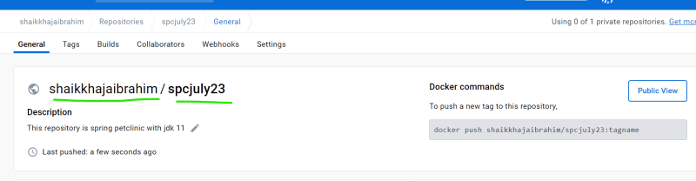
* specific image => Repo:tag => username/repo:tag
* After building the image tag the image with new naming format docker image tag spc:latest shaikkhajaibrahim/spcjuly23:2.4.2-jdk11

**Docker hub**

* To connect to docker hub

docker login

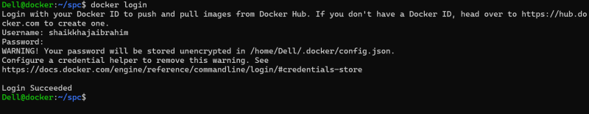  
* now push the image

docker image push shaikkhajaibrahim/spcjuly23:2.4.2-jdk11

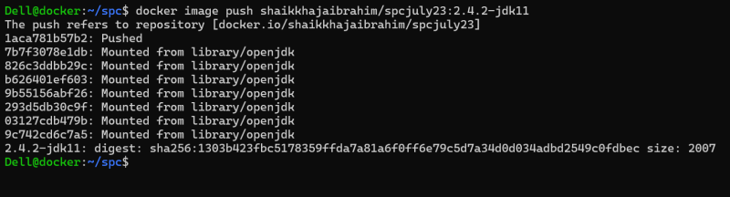  
* <https://hub.docker.com/repository/docker/shaikkhajaibrahim/spcjuly23/general> for image info  
* Now anyone connected to docker hub can run this application

docker container run -d -P --name spc1 shaikkhajaibrahim/spcjuly23:2.4.2-jdk11

**Exercise:** Try pushing your images to

* + docker hub
  + aws ecr
  + azure acr